Speech Hook Practice Worksheet
The Regular Opening (used so often that they are kinda dull) | 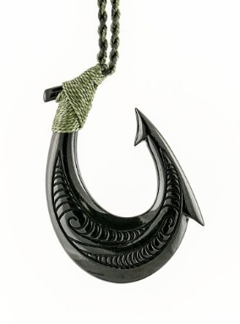 | Improved More Interesting Hook Opening
Hi, my name is….. |  | Do you actually know that I am the son/daughter of two amazing people? (rhetorical question)
My speech today is going to be about aliens. |  | Imagine if aliens landed on the planet today. (Imagine if…)
Today I’m going to talk about… |  | I bet you are wondering what I’m going to say to you today. (Add the word “you”)
I’ll be telling you about my favourite hobby of rugby. |  | Ritchie McCaw has been my idol since as long as I can remember. (Famous person)
In my speech I will tell you about how I train every day for swimming. |  | I feel like a fish out of water because I would rather be in the pool training than here today. (analogy)
I like mountain biking so that’s what my speech is about. |  | Crash! That was the sound as I hurtled off my mountain bike towards the summit of the second leg. (Onomatopoeia)
TIPS
Add the word “you” | Use onomatopoeia
Refer to someone famous | Create an imaginary idea to draw people in
Use a rhetorical question | Set up an analogy
Use repetition eg. The name’s Bond, James Bond.

Work individually or collaborate on your table to devise more interesting hooks for these opening lines.
As you know, my name is…
I’m from Alaska…
Today I will be talking about owls…
My hobby is sketching…

