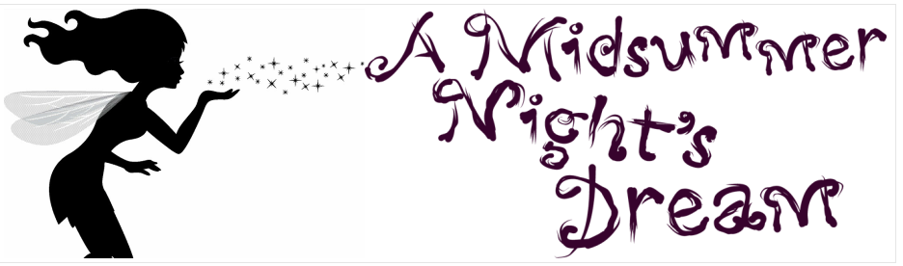
Look up these words in the dictionary or use the strategies suggested to explain the meaning.

Nuptial

Methinks

Wanes

She lingers my desires

Dowager

Withering

Four days will quickly steep themselves in night

Melancholy

Philostrate

Solemnity (solemnities)

Wooed (woo’d)

Doing thee injuries

Pert

Nimble

Revelling

