Listening with your eyes - Body Language
 | A Lesson to Teach  Listening Skills | 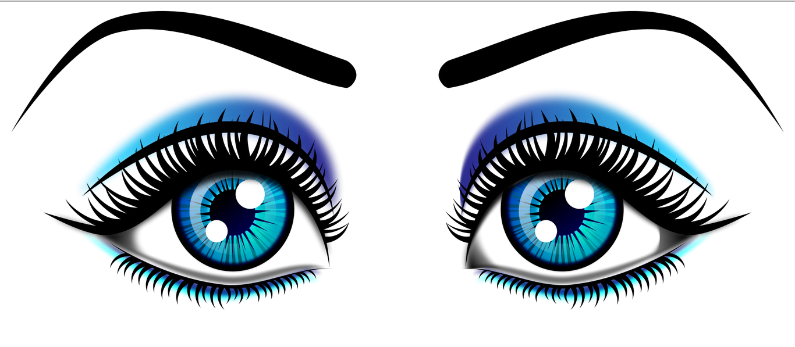

New Zealand Curriculum Achievement Objective
Show an understanding of ideas within, across, and beyond texts. Focussing particularly on the ‘beyond texts’ aspect and when studying towards a film unit.
Open with
Saying Hello to all students but changing body language so that you become increasingly annoyed with late comers or too many questions.
Explain to students
Tell students what you have been doing and ask if they noticed
Pair Activity
Ask students to discuss in pairs their experience of when somebody was cross with them. Ask them to mimic how they stood and what facial expressions/gestures they used.
Discuss
Do a brief class feedback to share ideas for weaker students. Include explanation that you can actually give non-verbal communication.
Note Taking
Give students instruction on body language focusing particularly on body language that contrasts although the same thing might be said Eg. This one for facial expressions: http://misslawler.weebly.com/film-techniques---facial-expressions.html
Activity
Give students a short script and ask them to practice speaking the script out loud in pairs.

Writing
Ask students to write down the choices they made about using body language to express the meaning behind their words.

Differentiation
Support weaker students in the role play and give them a vocabulary sheet to get them going.
Challenge advanced students to use more adjectives in their descriptions

Outcome
Students should write in their Learning Diary at the end of the lesson to explain that they have learned to read with their eyes.

