Matching Inference Cards Activity
The viewer can infer from her facial expression that she is terrified of the drop. | 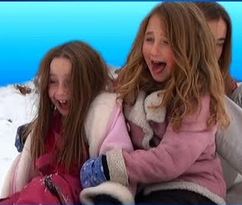
The inference is that the man has just jumped and is hoping to make a successful landing. | 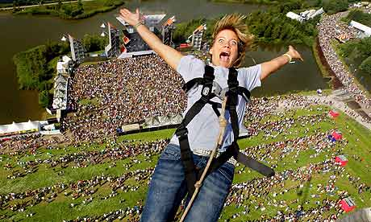
We can guess that the surfer is just learning because he seems off balance and everyone is watching him.
They are having fun because they have big smiles on their faces.
Several inferences are suggested by this picture. Perhaps the runner is tired after winning the race or maybe he has fallen and is disappointed to be injured. | 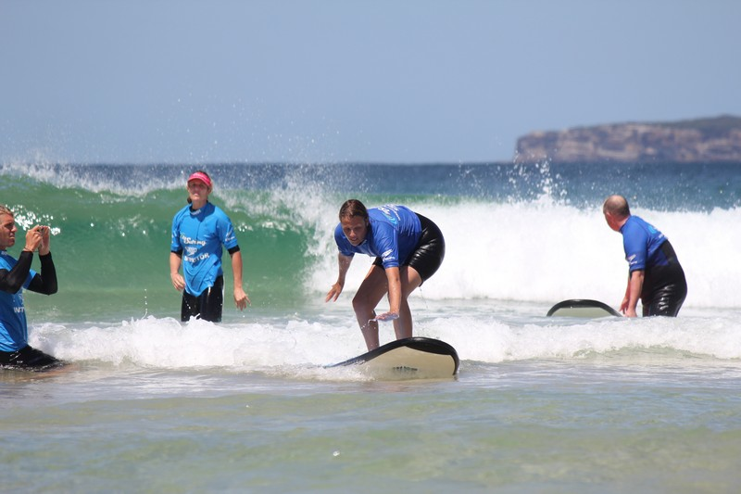
The viewer can infer that the girl has fallen and is wondering how badly she is injured.
His facial expression suggests that he is worried that he is going to make a successful try. | 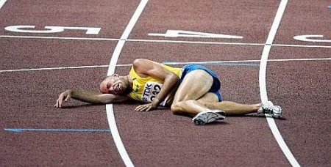
The picture suggests that the climber is feeling a sense of accomplishment after conquering the mountain. | 