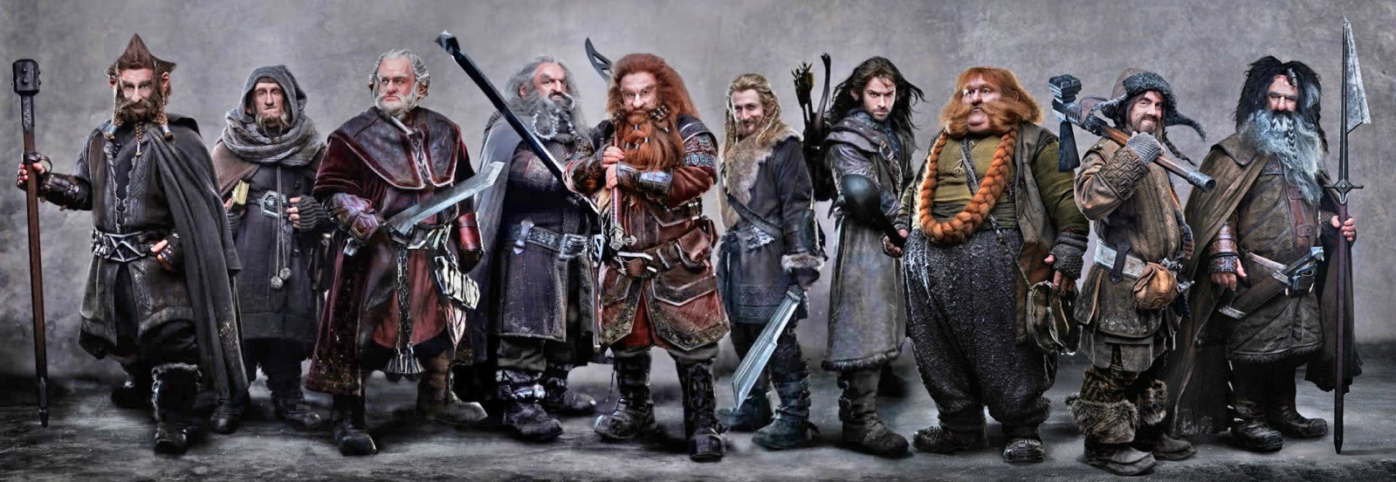
EXAMPLE COMPARE AND CONTRAST
There are some similarities between Dwarves and Trolls but there are also a great number of differences. Both Dwarves and Trolls are strong, tough and they have a lot of endurance. However Dwarves are quick learners which suggests that they are clever and Trolls are described as dim-witted and stupid. The Dwarves are easily offended and bear grudges but Trolls are thick-skinned which suggests that name calling will not hurt or offend them in anyway.

HOW TO COMPARE AND CONTRAST
Step 1
Study the example Venn diagram comparing Trolls and Dwarves and make sure you understand what aspects are the same and what is different.
Step 2
Complete your own Venn diagram comparing the texts. Steadily work through and identify what is the same and what is different. Use this list to prompt you: settings, characters, themes, events, authors and titles.
Step 3
Write up your structured comparison paragraph.
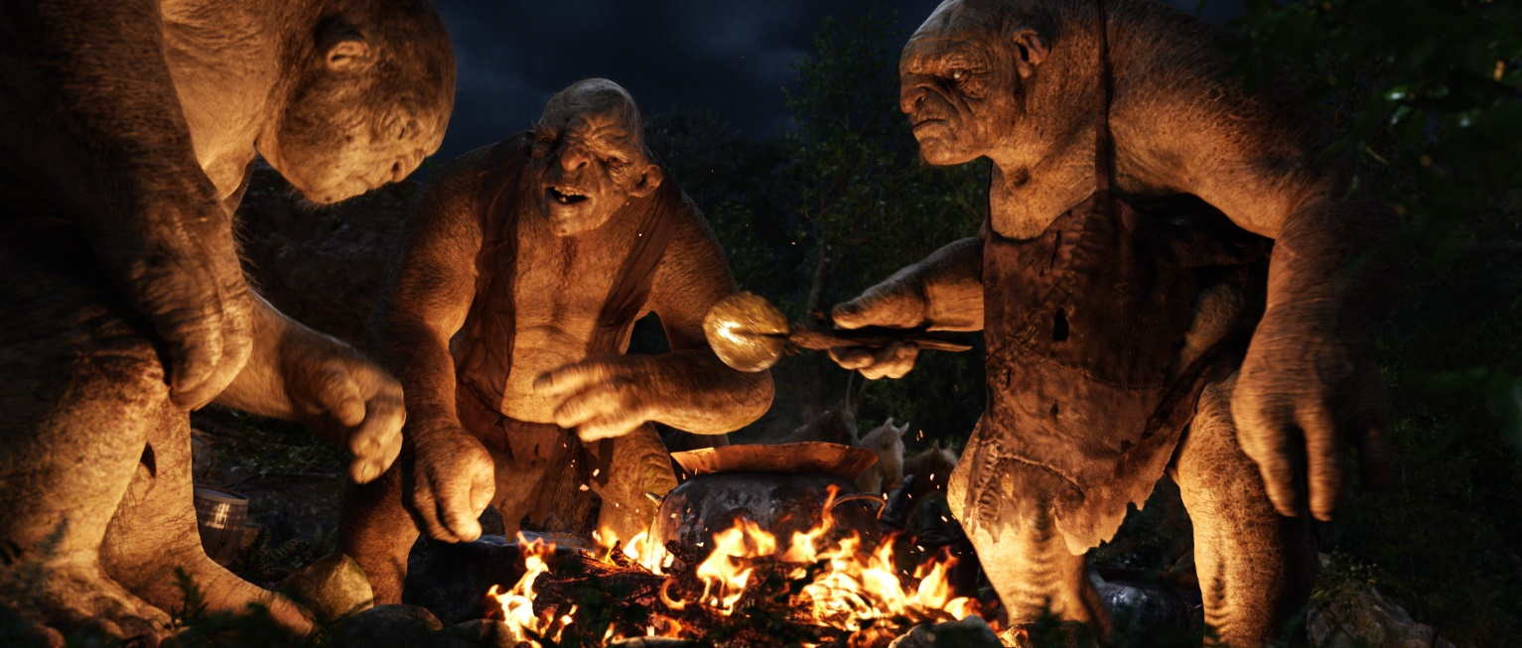
Dwarves Description
Dwarves were a proud and stern race and were made to be sturdy to resist the dangers of their time. They were physically very strong, had great endurance, especially in the ability to resist heat and cold, and they made light of heavy burdens. Dwarves lived longer than Men, often up to two hundred and fifty years. The Dwarf lords of the First and Second Age may have lived for several hundred years. Dwarves had the ability to learn new artisanal skills quickly, especially those dealing with metal or stone.
Dwarves were typically stubborn, secretive, and fiercely loyal to their friends. They cared greatly about mining, crafting, crafts, gold and gems, their acquisition of which often fueled the envy of the Elves. Dwarves were easily offended by rude comments, and had a propensity to hold long-lasting grudges. Dwarves were often seen as greedy, but their nature gave them resistance to many external influences, including to the evil of the Rings of Power given them. Whereas the Men who owned the nine Rings were corrupted and became the Nazgûl, the Dwarves were unaffected, save by an increase of their gold lust and hatred for anything that stood between them and what they perceived as their treasure.
Trolls Description
They were strong and vicious, but generally dim-witted and stupid at best. Some were described as being able to speak, while others appear to be as irrational as animals. The major weakness of at least some Trolls was that they turned to stone in sunlight, although it is evident they can be slain by weapons in spite of their extremely tough skin. It is stated that they were created by Melkor, although it's not clear exactly how. There is reference that sunlight will return them to the stone from which they were made in The Hobbit and The Lord of the Rings.
During the wars of Beleriand, Gothmog, the Lord of Balrogs, had a bodyguard of Trolls. While leading his men in a final stand to protect the retreat of Turgon and the continued secrecy of the Kingdom of Gondolin, the great warrior Húrin faced them, and due to Morgoth's emphatic orders to have Húrin captured alive, he managed to wipe them out. Their caustic blood, however, melted his axe, allowing orcs to swarm over him and bind him.
Venn Diagram
